# Creating the Azure Blob Storage Account

The User Interface for creating the Azure Storage Account has slightly changed recently. Please follow the instructions here if you get stuck!

1. Basics

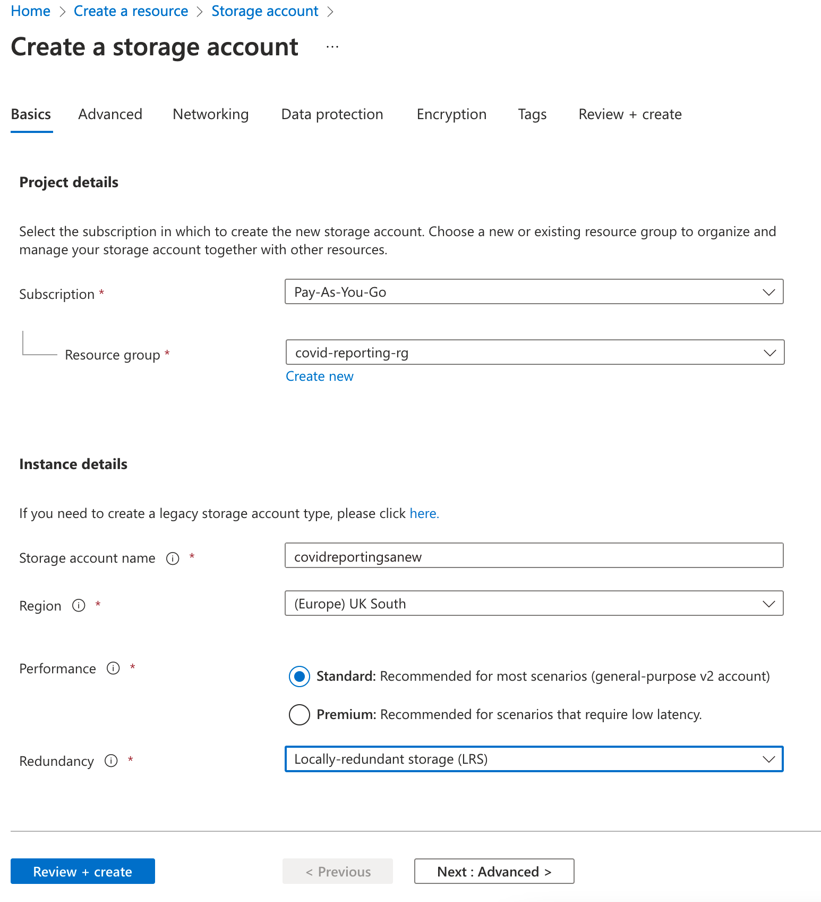

1. Advanced

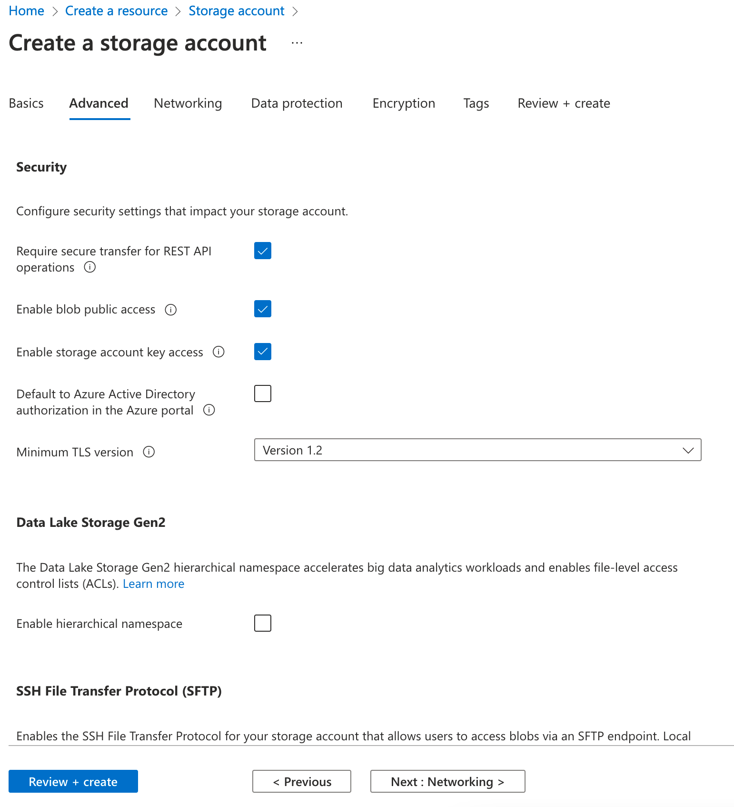

1. Networking

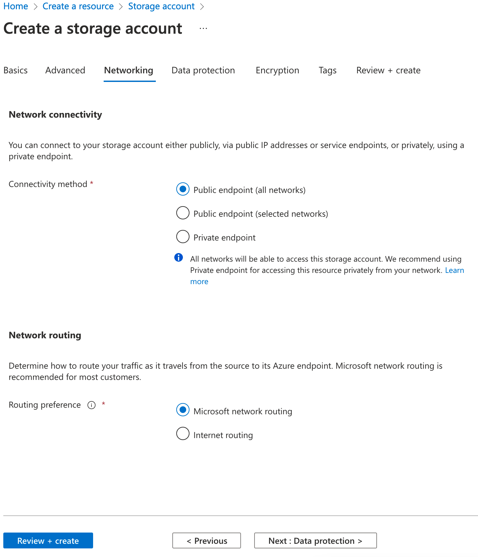

1. Data Protection – Untick the soft deletes

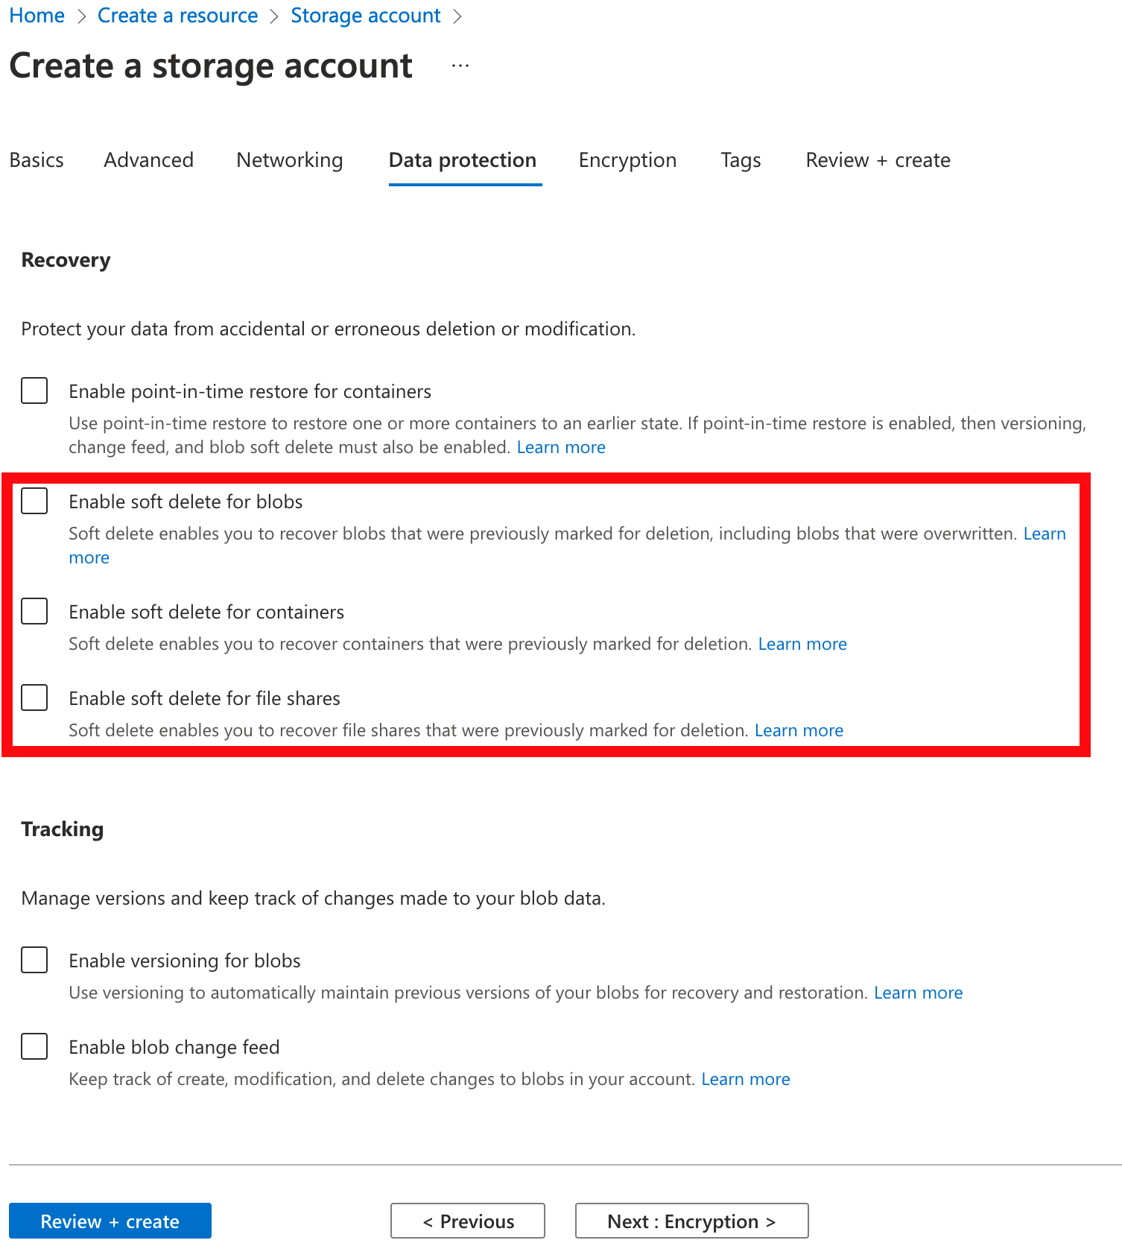

1. Encryption

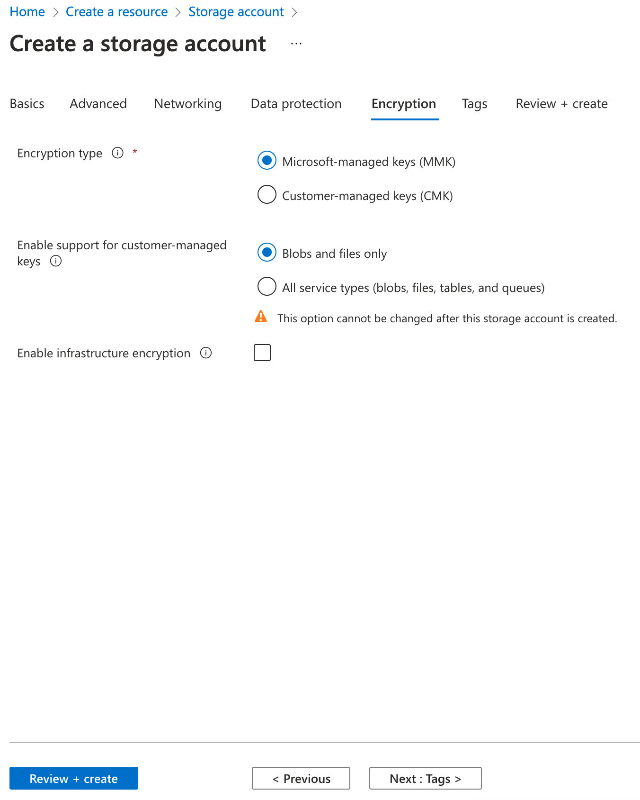

1. Tags

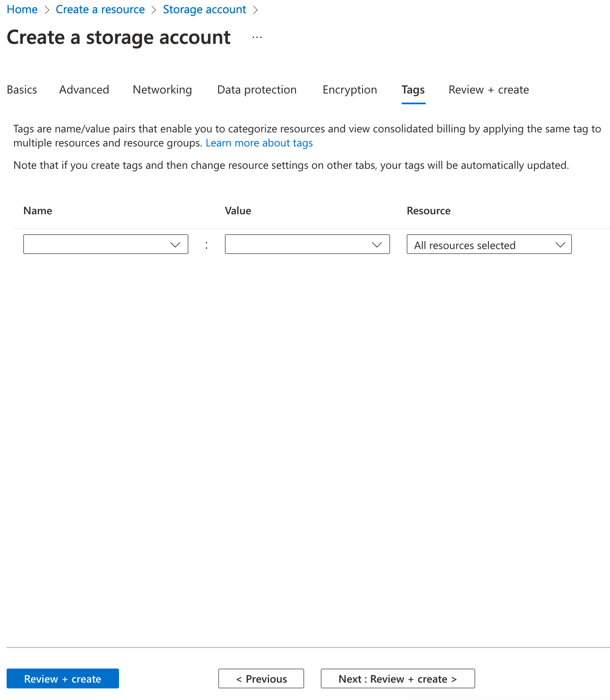

1. Review + Create – Click on Create

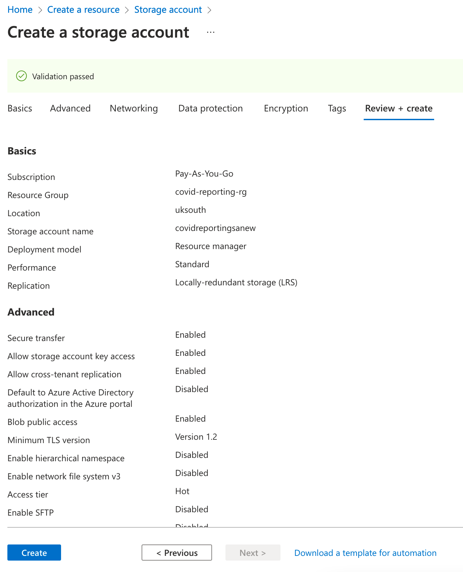

1. Storage Explorer is now hidden under the Storage browser. Please chick on the “Switch Back” button if you feel comfortable with the Storage Explorer UI

